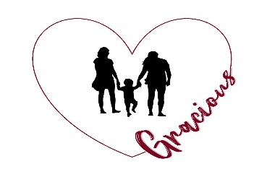 | GRACIOUS HEART RESOURCE FAMILY AGENCY

CLOTHING INVENTORY Boys 5-12

Child’s Name: _______________________ Resource Parent: ________________________

Check one: ☐ Initial inventory ☐ Quarterly for Month/Year of: ___________

ITEM | QUANTITY REQUIRED | QUANTITY ON HAND
Underpants | 8
Undershirts | 4-6
Slippers | 1
Pajamas | 2-4
Socks | 6-8
Dress Shoes | 1
Tennis Shoes/Sandals | 2
Sweater/Sweatshirt | 2
Shorts | 3
Casual Shirts | 3
T-Shirts | 3
Casual Pants | 4
Formal Shirt | 1
Formal Pants | 1
Jacket | 1
Swimsuit (if applicable) | 1
Bathrobe | 1
Duffel Bag/Suitcase | 1

Social Worker/Intake Signature Resource Parent Signature

______________________ _____________________

